**1.JUnit_Basic Testing Exercises**

**Exercise 1: Setting Up JUnit Scenario: You need to set up JUnit in your Java project to start writing unit tests. Steps: 1. Create a new Java project in your IDE (e.g., IntelliJ IDEA, Eclipse). 2. Add JUnit dependency to your project. If you are using Maven, add the following to your pom.xml: junit junit 4.13.2 test 3. Create a new test class in your project.**

**1.Creating the Java Class(Calculator.java):**  
public class Calculator {

public int add(int a, int b) {

return a + b;

    }

}

**2. Creating the Java Class(CalculatorTest.java):**import org.junit.Test;  
import static org.junit.Assert.*assertEquals*;  
public class CalculatorTest {  
 @Test  
 public void testAdd() {  
 Calculator calc = new Calculator();  
 int result = calc.add(2, 3);  
 *assertEquals*(5, result);  
 }  
}

**3.** **Add JUnit 5 & Mockito to pom.xml:**

<?xml version="1.0" encoding="UTF-8"?>

<project xmlns="http://maven.apache.org/POM/4.0.0"

xmlns:xsi="http://www.w3.org/2001/XMLSchema-instance"

xsi:schemaLocation="http://maven.apache.org/POM/4.0.0

http://maven.apache.org/xsd/maven-4.0.0.xsd">

<modelVersion>4.0.0</modelVersion>

<groupId>org.example</groupId>

<artifactId>JunitExample</artifactId>

<version>1.0-SNAPSHOT</version>

<properties>

<maven.compiler.source>21</maven.compiler.source>

<maven.compiler.target>21</maven.compiler.target>

<project.build.sourceEncoding>UTF-8</project.build.sourceEncoding>

</properties>

<dependencies>

<dependency>

<groupId>junit</groupId>

<artifactId>junit</artifactId>

<version>4.13.2</version>

<scope>test</scope>

</dependency>

</dependencies>

</project>

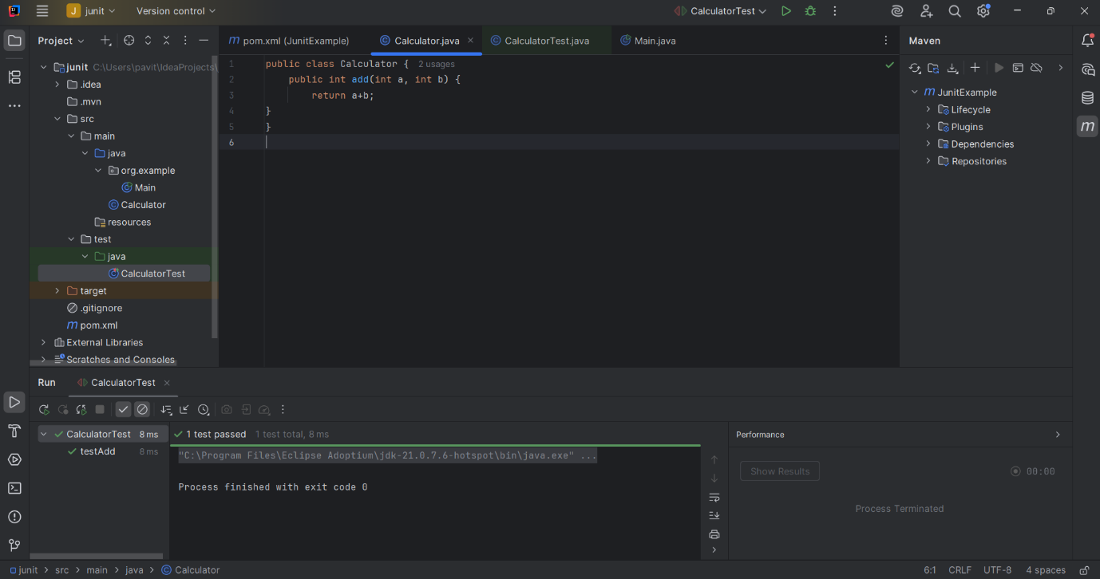**OUTPUT:**